Based on the content of the CRL, any resubmission of an NDA for OCA in NASH would require, at a minimum, successful completion of the long-term outcomes phase of the REGENERATE study

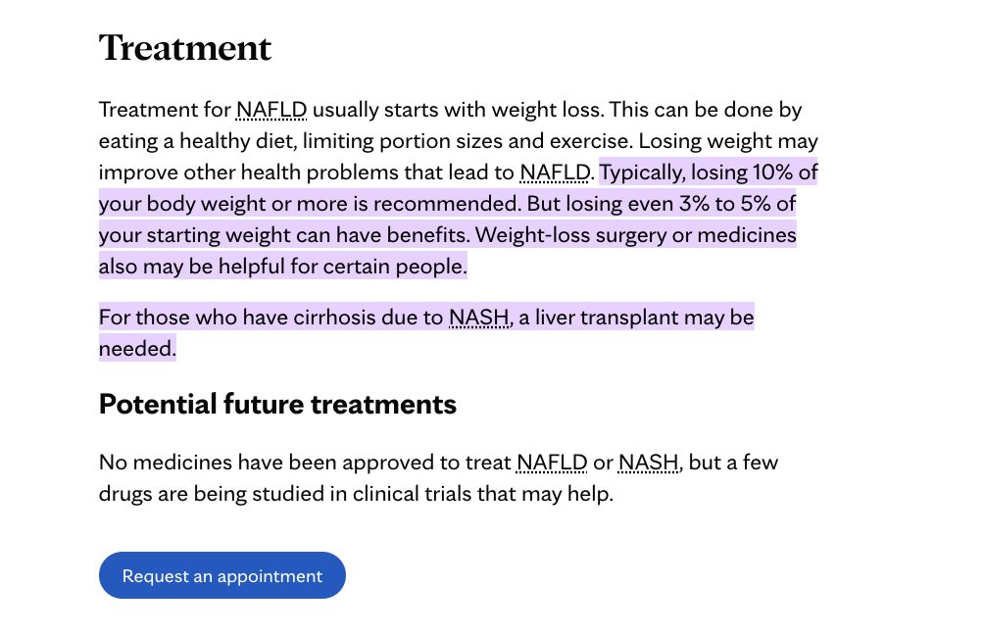

[**https://www.niddk.nih.gov/health-information/liver-disease/nafld-nash/treatment**](https://www.niddk.nih.gov/health-information/liver-disease/nafld-nash/treatment)

**The document discusses the clinical effectiveness and cost-effectiveness of obeticholic acid (OCA), an investigational drug for treating nonalcoholic steatohepatitis (NASH).**

**Key Clinical Effectiveness Points:**

**OCA improved liver histology compared to placebo in a phase 2 trial, but clinical significance is uncertain**

**OCA lowered liver enzymes more than placebo**

**No difference in quality of life measures between OCA and placebo**

**OCA increased bad cholesterol and decreased good cholesterol**

**Key Cost-Effectiveness and Budget Impact Points:**

**Using OCA's current annual price of $69,350, the incremental cost per QALY gained is $2.75 million, exceeding conventional willingness-to-pay thresholds**

**At a willingness-to-pay threshold of $150,000 per QALY, the annual price of OCA would need to be around $5,100**

**Assuming 10% uptake among eligible patients over 5 years, the estimated budget impact is $5.4 billion total or $1.08 billion annually**

**More robust longer-term data is expected from an ongoing phase 3 trial**

**The document concludes there is insufficient evidence to determine the clinical effectiveness of OCA for NASH, and the current price results in an unfavorable cost-effectiveness profile. More data is needed, especially on long-term clinical outcomes.**

**The document discusses the following potential harms of using obeticholic acid (OCA) to treat NASH:**

**Dyslipidemia (negative effects on cholesterol levels): OCA was associated with small but statistically significant increases in total and LDL cholesterol, as well as decreases in HDL cholesterol. This is concerning since NASH patients already have elevated cardiovascular risk.**

**Pruritus (itching): OCA treatment is associated with increased pruritus (23% vs 6% for placebo in one trial). However, this side effect reportedly led to little treatment discontinuation.**

**Uncertain long-term safety: As a new therapy for an off-label indication, there are still uncertainties around the long-term safety profile of OCA for NASH treatment. Specifically, the clinical significance of the lipid changes and potential unintended consequences of managing them are unclear.**

**So in summary, the main potential harms discussed are negative effects on cholesterol levels which could increase cardiovascular risk, bothersome itching, and uncertain long-term safety given the limited evidence currently available. The document states these need to be better characterized with additional trials.**

**Here are the key takeaways regarding the efficacy and safety of obeticholic acid (OCA) based on the additional data and analyses:**

**Efficacy:**

**Confirms statistically significant interim analysis showing OCA 25mg led to improvement of fibrosis by ≥1 stage in ~30% of patients after 18 months. This degree of histologic improvement is highly predictive of better clinical outcomes.**

**OCA 25mg demonstrated ability to not just regress, but also halt progression of fibrosis. Equally important treatment goal.**

**Improvements in liver enzymes, markers of injury/oxidative stress and measures of liver stiffness were sustained over time.**

**Safety:**

**Additional longer-term safety data show OCA was generally well tolerated over extended dosing period.**

**The confirmed antifibrotic effect combined with the largest safety database in NASH to date supports a positive benefit-risk profile with OCA 25mg in patients with pre-cirrhotic fibrosis due to NASH.**

**The phase 3 REGENERATE study is still ongoing, with final clinical outcome data yet to be collected and analyzed.**

**In summary, the additional efficacy analyses continue to support clinically meaningful antifibrotic and biochemical benefits with OCA 25mg, while longer-term safety data is reassuring regarding risks, supporting an overall positive benefit-risk profile specifically for patients with pre-cirrhotic NASH fibrosis. Final phase 3 data will provide definitive clinical outcomes assessment.**

**Fda calendar: 22/6/2023**

**News release: 23/6/2023 7:45**

研究结果：在2015年12月9日至2018年10月26日期间，共有1968名患有F1-F3纤维化阶段的患者被纳入研究并接受了至少一次研究治疗；主要分析中包括了931名F2-F3纤维化阶段的患者（分别为311名接受安慰剂治疗的患者，312名接受10毫克奥贝他酸治疗的患者和308名接受25毫克奥贝他酸治疗的患者）。纤维化改善终点在安慰剂组中有37名患者达到（占12%），在奥贝他酸10毫克组中有55名患者达到（占18%，p=0·045），在奥贝他酸25毫克组中有71名患者达到（占23%，p=0·0002）。非酒精性脂肪肝（NASH）病变解决终点未达到（安慰剂组中有25名患者达到[占8%]，奥贝他酸10毫克组中有35名患者达到[占11%，p=0·18]，奥贝他酸25毫克组中有36名患者达到[占12%，p=0·13]）。在安全人群（1968名F1-F3纤维化阶段的患者）中，最常见的不良事件是瘙痒感（安慰剂组中有123名[占19%]，奥贝他酸10毫克组中有183名[占28%]，奥贝他酸25毫克组中有336名[占51%]）；发生率通常为轻度至中度。总体安全性概况与先前的研究类似，严重不良事件的发生率在各治疗组之间相似（安慰剂组中有75名[占11%]，奥贝他酸10毫克组中有72名[占11%]，奥贝他酸25毫克组中有93名[占14%]）。

Top of Form

Bottom of Form